1.

P = {1, 2, 3, 8, 10}, Q = {8, 1, x, 3, 2}. If P = Q, what is the value of x?
A.
1
B.
2
C.
3
D.
8
E.
10

2.

If Y = {house, tree} and V = {cat, house, tree} which of the following is true of Y and V?
A.
Y = V
B.
Y ⊂ V
C.
V ⊂ Y
D.
V ∈ Y
E.
Y ∈ V

3.

The following addition is in base ten. Find the missing addend.
 | 2 | 3 | 4 | 5
+ | 1 | 0 | 4 | 5
 | * | * | * | *
 | 5 | 1 | 1 | 0
A.
1300
B.
1720
C.
2765
D.
4065
E.
9500

4.

Given that 2² x 3² x 7 = 252, find the least number that should be multiplied by 252 to make the product a perfect square.
A.
2
B.
3
C.
6
D.
7
E.
252

5.

Write 4687.02 in standard form.
A.
46.8702 x 10³
B.
46.8702 x 10⁴
C.
4.68702 x 10⁵
D.
4.68702 x 10³
E.
0.468702 x 10⁴

6.

Convert 11001_{two} to a decimal numeral.
A.
6
B.
7
C.
14
D.
25
E.
50

7.

A boy spent
2
7
of his pocket money on transport and
1
5
on sweets. What fraction of his pocket money does he spend on transport and sweets?
A.
2
35
B.
3
35
C.
1
7
D.
17
35
E.
18
35

8.

The product of three numbers is 1197. Two of the numbers are 3 and 19. Find the third number.
A.
21
B.
54
C.
210
D.
544
E.
1175

9.

Find the GCF (HCF) of 2³ × 3² and 2³ × 3⁴.
A.
8
B.
9
C.
72
D.
81
E.
648

10.

Use the diagram below to answer the question below.
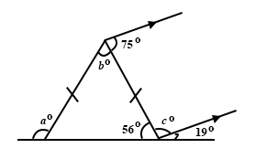
Find the value of a°
A.
68°
B.
75°
C.
105°
D.
112°
E.
124°

11.

Use the diagram below to answer the question below.
What is the value of b°?
A.
68°
B.
75°
C.
105°
D.
112°
E.
124°

12.

Use the diagram below to answer the question below.
What is the value of c°?
A.
68°
B.
75°
C.
105°
D.
112°
E.
124°

13.

Simplify 2ab² × 3a²b
A.
5a³b³
B.
5a²b²
C.
6a³b³
D.
5a²b²
E.
36ab

14.

In the relation v = u+ at, find v when u = 6, a = 10 and t = 2
A.
18
B.
26
C.
32
D.
48
E.
120

15.

The marks obtained by 10 children in a mental drill are: 0, 1, 3, 3, 5, 7, 8, 9, 9, 9.
Use this information to answer the question below.
What is the modal mark?
A.
3
B.
5
C.
7
D.
8
E.
9

16.

The marks obtained by 10 children in a mental drill are: 0, 1, 3, 3, 5, 7, 8, 9, 9, 9.
Use this information to answer the question below.
Find the median mark.
A.
3
B.
5
C.
6
D.
7
E.
8

17.

The marks obtained by 10 children in a mental drill are: 0, 1, 3, 3, 5, 7, 8, 9, 9, 9.
Use this information to answer the question below.
Calculate the mean mark.
A.
–54
B.
5.4
C.
10
D.
54
E.
540

18.

The marks obtained by 10 children in a mental drill are: 0, 1, 3, 3, 5, 7, 8, 9, 9, 9.
Use this information to answer the question below.
What is the probability that a child chosen at random scored 3 marks?
A.
2
54
B.
3
54
C.
2
10
D.
3
10
E.
1
3

19.

A trader received a commission of 12
1
2
% on sales made in a month. His commission was ₵35,000.00. Find his total sales for the month.
A.
₵36,250.00
B.
₵59,750.00
C.
₵245,000.00
D.
₵280,000.00
E.
₵315,000.00

20.

A map of a large town is drawn to the scale of 1 : 100,000. What is the distance in kilometres (km) represented by a line segment 4 cm along the map?
A.
0.04 km
B.
0.4 km
C.
4 km
D.
40 km
E.
400 km

21.

Adjoa and Ama share ₵600.00 between them in the ratio 3 : 2. Find Adjoa's share.
A.
₵200.00
B.
₵240.00
C.
₵300.00
D.
₵360.00
E.
₵400.00

22.

Simplify:
2a
3
-
a - b
2
.
A.
a - 3
B.
a - 3b
6
C.
a + 3b
6
D.
a + 3b
E.
a - b

23.

If a⁶ ÷ a⁴ = 64. Find a
A.
8
B.
10
C.
16
D.
20
E.
24

24.

Find one-hundredth of 1.0756
A.
107.56
B.
10.756
C.
0.01756
D.
0.010756
E.
0.001756

25.

What is the rule for this mapping?
x | 1 | 2 | 3 | 4 | 5
↓ | ↓ | ↓ | ↓ | ↓ | ↓
y | 1 | 3 | 5 | 7 | 9
A.
x→2x - 1
B.
x→2(x - 1)
C.
x→2x + 1
D.
x→2(x + 1)
E.
x→2x - 1

26.

The circumference of a circular track is 440 m. Find the diameter of this track.
[Take π =
22
7
]
A.
70 m
B.
140 m
C.
280 m
D.
690 m
E.
1400 m

27.

If r =
(
3
1
)
and s =
(
-2
1
)
, calculate 6(r + 2s).
A.
(
-1
3
)
B.
(
1
3
)
C.
(
7
3
)
D.
(
-6
18
)
E.
(
6
18
)

28.

Which of the following would you use to measure an angle?
A.
Ruler
B.
A pair of compasses
C.
A set square
D.
A protractor

29.

Express the ratio of 64 cm to 48 cm in its simplest form.
A.
3 : 4
B.
4 : 3
C.
16 : 12
D.
12 : 16
E.
64 : 48

30.

In the diagram, P→P¹, Q→Q¹, R→R¹, where P¹Q¹R¹ is an enlargement.
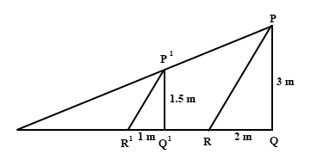
What is the scale factor of this enlargement?
A.
–2
B.
1
3
C.
1
2
D.
2
E.
3

31.

In the diagram, P→P¹, Q→Q¹, R→R¹, where P¹Q¹R¹ is an enlargement.
If |PR| = 3.6 m, what is |P¹R¹|?
A.
–7.2 m
B.
–1.8 m
C.
1.2 m
D.
1.8 m
E.
7.2 m

32.

Find the tangent of the angle marked y in the diagram below.
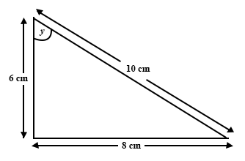
A.
3
5
B.
3
4
C.
4
5
D.
4
3
E.
5
3

33.

Kojo paid ₵270,000.00 for a TV set after he had been given a discount of 10%. Find the marked price.
A.
₵300,000.00
B.
₵297,000.00
C.
₵280,000.00
D.
₵260,000.00
E.
₵243,000.00

34.

In a secondary school class, 23 pupils study Economics, 6 pupils study both Government and Economics. 48 pupils study either Government or Economics or both.
Use this information to answer the question below.
What is the total number of pupils who study Government?
A.
17
B.
23
C.
24
D.
25
E.
31

35.

In a secondary school class, 23 pupils study Economics, 6 pupils study both Government and Economics. 48 pupils study either Government or Economics or both.
Use this information to answer the question below.
How many pupils study only Government?
A.
17
B.
23
C.
24
D.
25
E.
31

36.

In a secondary school class, 23 pupils study Economics, 6 pupils study both Government and Economics. 48 pupils study either Government or Economics or both.
Use this information to answer the question below.
How many pupils study only Economics?
A.
17
B.
23
C.
24
D.
25
E.
31

37.

When a certain number is subtracted from 10 and the result is multiplied by 2, the final result is 4. Find the number.
A.
8
B.
12
C.
16
D.
24
E.
32

38.

From the diagram below, calculate the bearing of point X from Y.
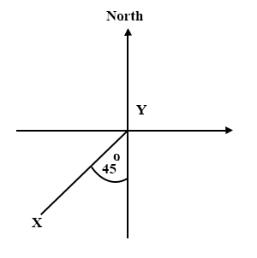
A.
035°
B.
045°
C.
135°
D.
145°
E.
225°

39.

If 22% of the length of a rope is 55 cm, find the full length of the rope.
A.
12.1 cm
B.
25 cm
C.
121 cm
D.
250 cm
E.
2500 cm

40.

Which of these best describes the given construction?
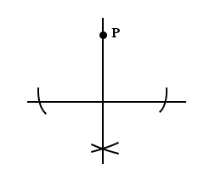
A.
Bisecting a line
B.
Constructing the bisector of a line segment
C.
Constructing the perpendicular to a line
D.
Constructing a perpendicular to a given line from a point outside the line
E.
Constructing a perpendicular to a given line through a point on the line

